HOW DO I GET MY TEST RESULTS?

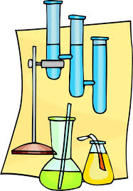
Blood test, urine test, x-ray, scan, smear test, histology…

- Results from local hospitals go directly into your personal records

- You can view your records with Online Access, 24 hours a day

- Your Online Access account is ready. Please activate as soon as possible.

- Activation takes only 5 minutes. Please ask the reception for your log in details.

- If you have forgotten your log in details, our team can help you recover.

14.06.2017

